Grade 8 ELA and Literacy

For each of these SBAC examples, tell
- The item type (selected response, constructed response, technology enhanced items/tasks, or performance tasks.
- The claim(s) (primary claims and secondary claims
- Depth of Knowledge level

The Performance Task will take 105 minutes in one session.

Student Directions: Part 1 (35 minutes) Your assignment: You will read a chart and article about techniques author’s use to help readers get to know characters and some examples of these techniques. You will answer some questions about the sources. Then you will plan, write, and revise your own narrative using at least two of the characterization techniques discussed. 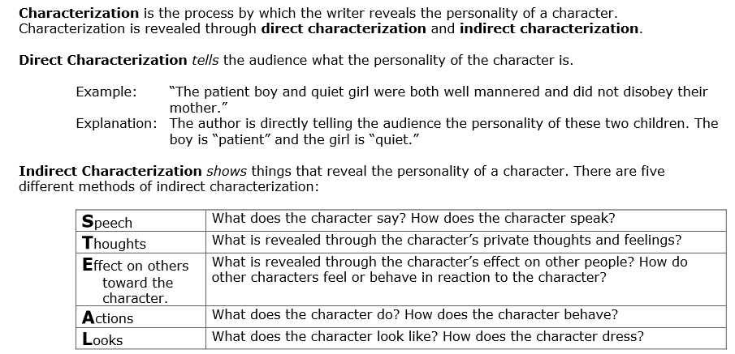
Steps you will be following: In order to plan and compose your narrative, you will: In this lesson, The Cat in the Hat is used as a primer to teach students how to analyze a literary work using the literary tools of plot, theme, characterization, and psychoanalytical criticism. In the first session, students use a plot handout to identify the elements of plot and theme for The Cat in the Hat. Session Two introduces psychoanalytic criticism as students classify the characters from the story, using the Id, Ego, and Superego. Students then develop an argument stating the psychological personality for each character. They gather evidence supporting their arguments by identifying examples of indirect characterization in the text. Finally, students refine their analysis and develop an analytical essay.

1. Read a chart and an article about different characterization techniques.

2. Read literary excerpts that provide examples of these techniques.

3. Answer questions about the sources.

4. Plan, write, and revise your narrative.

Directions for beginning: You will now read the sources. Take notes because you may want to refer back to your notes while writing your narrative. You can refer back to any of the sources as often as you like. (source 1) (source 2) (source 3)

Questions Use your remaining time to answer the questions below. Your answers to these questions will be scored. Also, they will help you think about the sources you’ve read and viewed, which should help you write your narrative. You may click on the appropriate buttons to refer back to the sources when you think it would be helpful. You may also refer to your notes. Answer the questions in the spaces provided below them.

1. Match each literary excerpt with the characterization technique it demonstrates. A. physical description B. actions C. dialogue D. thoughts
1. excerpt 1
2. excerpt 2
3. excerpt 3
4. excerpt 4

5. Explain why it is best for authors to use multiple techniques to develop characters. Use details from the sources to support your answer.

6. In a short story, readers must get to know characters very quickly. Analyze which characterization technique, or combination of techniques, is best to use for introducing a character quickly. Use details from the sources to support your answer.

7. Explain why all of these sources are useful for understanding different characterization techniques. Use details from the sources to support your answer.

Part 2 (70 minutes) You now have 70 minutes to plan, draft, and revise your narrative. You may refer to the sources and the answers you wrote to the questions in part 1, but you cannot change those answers.

Your Assignment: Write a short story using at least two characterization techniques to introduce your main character quickly. Use this planning guide to make sure you get started quickly and keep your story short enough to finish in one hour.

Character
1. Who will be the main character of your story? This can be a real or imaginary character.
2. Which characterization techniques will you use?

Setting
1. Where will your story take place?
2. Will your story take place in the past, the present, or the future?

Plot
1. Problem a. What is the problem your character will solve? b. How will the problem be solved?
2. Sequence of Events a. How will your story begin? b. What will happen to move your story from the beginning to the end? c. How will your story end?

Theme
1. What is the lesson or message that can be learned from the story?

How your essay will be scored: The people scoring your essay will be assigning scores for
1. Narrative focus – how well you maintain your focus, and establish a setting, narrator and or characters, and point of view
2. Organization – how well the events logically flow from beginning to end using effective transitions and how well you stay on topic throughout the essay
3. Elaboration of narrative – how well you elaborate with details, dialogue, and description to advance the story or illustrate the experience 4. Language and Vocabulary – how well you effectively express experiences or events using sensory, concrete, and figurative language that is appropriate for your purpose
5. Conventions – how well you follow the rules of usage, punctuation, capitalization, and spelling.

Now begin work on your narrative. Manage your time carefully so that you can: • write your narrative • revise and edit the final draft of your narrative Word-processing tools and spell check are available to you.~

Question 4 Stimulus Text:
Alicia has to write a narrative essay for her English class about a series of events related to her school life. Here is the beginning of her essay:

How I Beat the Alarm Clock

“RINNGGG!” At 6:30 AM, the alarm clock goes off next to my head, but I am already awake. I can hear you ask, “How does she beat the alarm clock?” Well, it isn’t easy, but with a few changes in habit, you too can wake up before the alarm clock goes off.

It’s true that like a lot of teens, I used to stay up late reading, listening to music on my headphones, or even studying until 11:00 PM. I was always really tired the next morning when my alarm clock went off at 6:30 AM, so I’d hit the snooze button again and again until my mom had to wake me up at 7:30 AM.

I knew I had to solve this problem, so I came up with a plan that worked. I started going to bed thirty minutes earlier. I put my feet on the floor and stood up instead of slapping “Snooze.” I found myself tired by 10:00 PM. Because I had been awake since 6:30 in the morning, 10:00 PM now seemed really late. From then on, I fell asleep quickly and woke up before my alarm went off.

Now I’m on time to school every day. If you’re late a lot, maybe this plan will work for you, too!

Item Stem: Alicia wants to revise the highlighted part of her essay to make the steps of her plan clearer. What is the best way for her to add transition words and phrases?

Options:
A. When I was done, I started going to bed thirty minutes earlier. Sometimes I put my feet on the floor and stood up instead of slapping “Snooze.” I for a while found myself tired by 10:00 PM since I had been up since 6:30 AM.

B. After that, I started going to bed thirty minutes earlier. Before my alarm went off, I put my feet on the floor and stood up instead of slapping “Snooze.” I finally found myself tired by 10:00 PM since I had been up since 6:30 AM.

C. First I started going to bed thirty minutes earlier. When my alarm went off, I put my feet on the floor and stood up instead of slapping “Snooze.” I soon found myself tired by 10:00 PM since I had been up since 6:30 AM. D. Next I started going to bed thirty minutes earlier. I put my feet on the floor and stood up instead of slapping “Snooze” when it was time to get up. I quickly found myself tired by 10:00 PM since I had been up since 6:30 AM.

List the skills your students will need in order to be successful on this test:

What activities will you need to do for your students to be prepared for SBAC?

