Discussion Points:

What are the outcomes that are expected of students from this task?

What are the specific student learning objectives?

Are the issues in this task real to your students?

What student product(s) and/or performances will provide evidence of student attainment of outcomes?

Do students have a choice regarding products and/or performances?

List the skills your students will need in order to be successful on this test.

What activities will you need to do for your students to be prepared for this task?

Title: The Internet: Fundamental Right or Luxury?

lmost four in five people around the world believe that access to the internet is a fundamental right, a poll for the BBC World Service suggests.
The survey - of more than 27,000 adults across 26 countries - found strong support for net access on both sides of the digital divide.
Countries such as Finland and Estonia have already ruled that access is a human right for their citizens. International bodies such as the UN are also pushing for universal net access. "The right to communicate cannot be ignored," Dr Hamadoun Toure, secretary-general of the International Telecommunication Union (ITU), told BBC News. "The internet is the most powerful potential source of enlightenment ever created." He said that governments must "regard the internet as basic infrastructure - just like roads, waste and water".
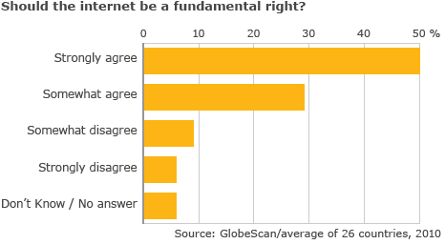
"We have entered the knowledge society and everyone must have access to participate."

The survey, conducted by GlobeScan for the BBC, also revealed divisions on the question of government oversight of some aspects of the net. Web users questioned in South Korea and Nigeria felt strongly that governments should never be involved in regulation of the internet. However, a majority of those in China and the many European countries disagreed. In the UK, for example, 55% believed that there was a case for some government regulation of the internet.
Rural retreat
The finding comes as the UK government tries to push through its controversial Digital Economy Bill.
As well as promising to deliver universal broadband in the UK by 2012, the bill could also see a so-called "three strikes rule" become law. This rule would give regulators new powers to disconnect or slow down the net connections of persistent illegal file-sharers. Other countries, such as France, are also considering similar laws.
Recently, the EU adopted an internet freedom provision, stating that any measures taken by member states that may affect citizen's access to or use of the internet "must respect the fundamental rights and freedoms of citizens". In particular, it states that EU citizens are entitled to a "fair and impartial procedure" before any measures can be taken to limit their net access. The EU is also committed to providing universal access to broadband. However, like many areas around the world the region is grappling with how to deliver high-speed net access to rural areas where the market is reluctant to go. Analysts say that is a problem many countries will increasingly have to deal with as citizens demand access to the net.
The BBC survey found that 87% of internet users felt internet access should be the "fundamental right of all people". More than 70% of non-users felt that they should have access to the net. Overall, almost 79% of those questioned said they either strongly agreed or somewhat agreed with the description of the internet as a fundamental right - whether they currently had access or not.
Free speech
Countries such as Mexico, Brazil and Turkey most strongly support the idea of net access as a right, the survey found. More than 90% of those surveyed in Turkey, for example, stated that internet access is a fundamental right - more than those in any other European Country.South Korea - the most wired country on Earth - had the greatest majority of people (96%) who believed that net access was a fundamental right. Nearly all of the country's citizens already enjoy high-speed net access. The survey also revealed that the internet is rapidly becoming a vital part of many people's lives in a diverse range of nations. In Japan, Mexico and Russia around three-quarters of respondents said they could not cope without it. Most of those questioned also said that they believed the web had a positive impact, with nearly four in five saying it had brought them greater freedom.
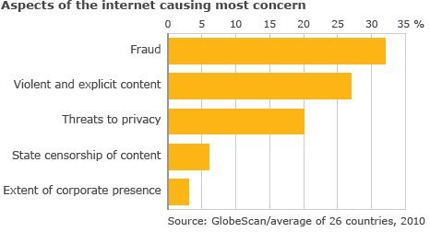
However, many web users also expressed concerns. The dangers of fraud, the ease of access to violent and explicit content and worries over privacy were the most concerning aspects for those questioned.
A majority of users in Japan, South Korea and Germany felt that they could not express their opinions safely online, although in Nigeria, India and Ghana there was

Excerpt from: Internet Access Is Not a Human Right
Technology is an enabler of rights, not a right itself. There is a high bar for something to be considered a human right. Loosely put, it must be among the things we as humans need in order to lead healthy, meaningful lives, like freedom from torture or freedom of conscience. It is a mistake to place any particular technology in this exalted category, since over time we will end up valuing the wrong things. For example, at one time if you didn’t have a horse it was hard to make a living. But the important right in that case was the right to make a living, not the right to a horse. Today, if I were granted a right to have a horse, I’m not sure where I would put it.
The best way to characterize human rights is to identify the outcomes that we are trying to ensure. These include critical freedoms like freedom of speech and freedom of access to information — and those are not necessarily bound to any particular technology at any particular time. Indeed, even the United Nations report, which was widely hailed as declaring Internet access a human right, acknowledged that the Internet was valuable as a means to an end, not as an end in itself.
What about the claim that Internet access is or should be a civil right? The same reasoning above can be applied here — Internet access is always just a tool for obtaining something else more important — though the argument that it is a civil right is, I concede, a stronger one than that it is a human right. Civil rights, after all, are different from human rights because they are conferred upon us by law, not intrinsic to us as human beings.
While the United States has never decreed that everyone has a “right” to a telephone, we have come close to this with the notion of “universal service” — the idea that telephone service (and electricity, and now broadband Internet) must be available even in the most remote regions of the country. When we accept this idea, we are edging into the idea of Internet access as a civil right, because ensuring access is a policy made by the government. Yet all these philosophical arguments overlook a more fundamental issue: the responsibility of technology creators themselves to support human and civil rights. The Internet has introduced an enormously accessible and egalitarian platform for creating, sharing and obtaining information on a global scale. As a result, we have new ways to allow people to exercise their human and civil rights.

Excerpt from Reading 3United Nations report: Internet access is a human right
June 3, 2011 |
Internet access is a human right, according to a United Nations report released on Friday.
"Given that the Internet has become an indispensable tool for realizing a range of human rights, combating inequality, and accelerating development and human progress, ensuring universal access to the Internet should be a priority for all states," said the report from Frank La Rue, a special rapporteur to the United Nations, who wrote the document "on the promotion and protection of the right to freedom of opinion and expression."
La Rue said in his report that access to the Internet is particularly important during times of political unrest, as demonstrated by the recent "Arab Spring" uprisings in Tunisia and Egypt, among other countries.
The Special Rapporteur believes that the Internet is one of the most powerful instruments of the 21st century for increasing transparency in the conduct of the powerful, access to information, and for facilitating active citizen participation in building democratic societies.
Indeed, the recent wave of demonstrations in countries across the Middle East and North African region has shown the key role that the Internet can play in mobilizing the population to call for justice, equality, accountability and better respect for human rights.
The report notes that while the Internet has been in existence since the 1960s, it is the way people now use the Internet, across the world and across age groups, with "incorporation into virtually every aspect of modern human life," that makes the Internet an unprecedented force. According to the International Telecommunication Union, the total number of Internet users worldwide is now over 2 billion," the report said, also pointing out the huge growth in the number of active users on Facebook, which has surged from 150 million in 2009 to 600 million this year.
La Rue also urges governments to eschew laws that allow for people's access to the Internet to be blocked. As such, the Internet can be a tool of empowerment and aid in the protection of and access to other human rights -- as well as contributing to growth economically, socially and politically -- benefiting mankind as a whole. Such platforms are particularly valuable in countries where there is no independent media, as they enable individuals to share critical views and to find objective information.
Student Directions:
Part 1 (35 minutes)
Your assignment:
You will read several articles, taking notes on these sources and answering three questions about the sources. You will then prepare and deliver an oral presentation concerning your opinion of the issue of whether Internet access is a fundamental right.

Questions
Use your remaining time to answer the questions below. Your answers to these questions will be scored. Also, they will help you think about the sources you’ve read and viewed, which should help you write your presentation. You may click on the appropriate buttons to refer back to the sources when you think it would be helpful. You may also refer to your notes. Answer the questions in the spaces provided below them.

1) Of the three source articles, which article most clearly appeals to the reader’s emotions? Support your answer
with details from the article you choose.
2) Which source provides the most relevant information for a reader who is interested in what surveys reveal about Internet rights? Support your answer with details from the article you choose.
3) Of the three sources which contains the most ideas with which you agree? Explain why you agree with the
arguments presented in the article. Support your answer with details from the article.

Part 2 (70 minutes)
You will now have 70 minutes to review your notes and sources, plan, draft, and deliver your speech. While you may use your notes and refer to the sources, you must work on your own. You may also refer to the answers you wrote to earlier questions, but you cannot change those answers. Now read your assignment
and the information about how your speech will be scored, and then begin your work.

Your Assignment
The availability of Internet access varies in many places around the world. Some countries have taken steps to increase people’s access to the Internet, while other countries feel it is up to the individual to gain access. Some countries even restrict personal access to the Internet. Is access to the Internet a human right or a luxury? You will write a draft of a speech and create any supplementary materials you may need for your presentation.Support your opinion with details from the sources you have read.

Math example:

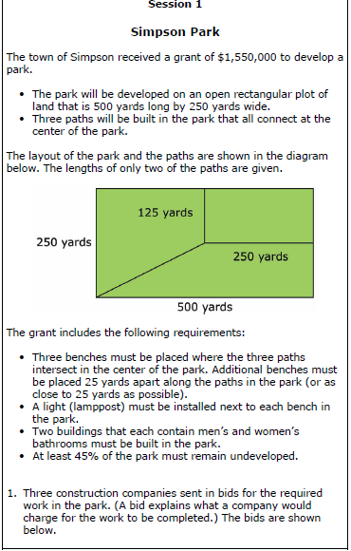
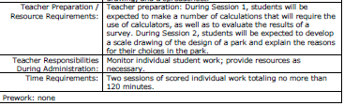

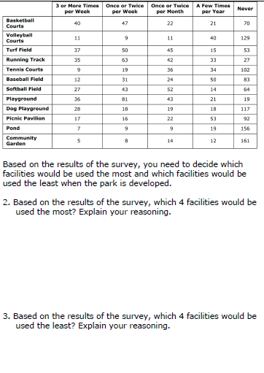
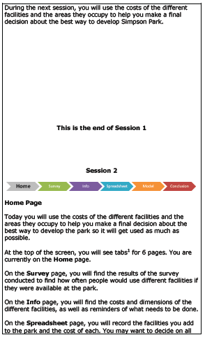

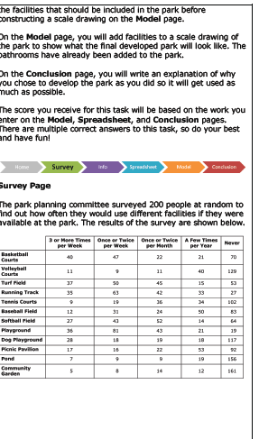
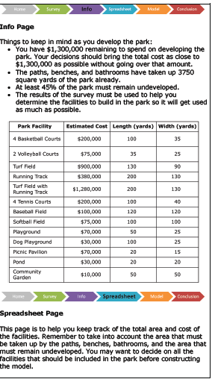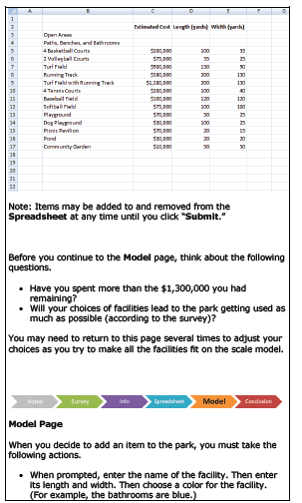
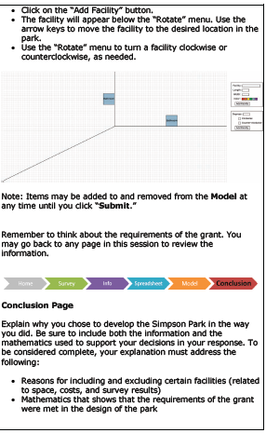

Sections of this assessment

- Compare the costs of different bids,
- Determine what facilities should be given priority in the park,
- Develop a scale drawing of the best design for the park and an explanation of the choices made
- Use a calculator, an applet to construct the scale drawing, and a spreadsheet

