Discussion Points:

What are the outcomes that are expected of students from this task?

What are the specific student learning objectives?

Are the issues in this task real to your students?

What student product(s) and/or performances will provide evidence of student attainment of outcomes?

Do students have a choice regarding products and/or performances?

List the skills your students will need in order to be successful on this test.

What activities will you need to do for your students to be prepared for this task?
5th Grade ELA: Pollution on Land and in Space
Reading 1
Pollution
There are many kinds of pollution. Some kinds of pollution affect the air, soil, and water. Other pollution is in the form of noise and light.

Air pollution is caused by microscopic bits of trash, droplets of liquid or harmful gases in the air. Breathing air with these types of debris is harmful. There are two main types of air pollution: primary and secondary. Primary pollutants enter the air directly. Some examples of primary pollutants are smoke from factories or car exhaust. Secondary pollutants are chemicals that mix together to dirty the air. For example, exhaust smoke from vehicles mixes with factory smoke to form dangerous combinations.

Soil pollution is caused when harmful chemicals get into soil. These chemicals seep into soil through accidental spillage or purposeful dumping. Pesticides or chemicals used to kill insects, leak from holding tanks, and oil leaks into underground water supply systems.

Water pollution can have a far-reaching impact on the environment. Some scientists believe that water pollution is the largest cause of death and disease in the world. Some other forms of pollution are not as well known. Noise and light pollution also have negative effects on the environment. Noise pollution is caused by the loud sounds made by cars, airplanes, and factories. People who are exposed to loud noises for long periods of time can suffer from high blood pressure, heart problems, sleep disturbances, and hearing problems. In animals, noise pollution can cause communication and reproductive problems. For some animals, noise can even affect the ability to navigate, or find the way to breeding grounds or away from harm. Noise from underwater sonar equipment has been known to confuse whales. When a whale responds to the sonar as if it were another whale, it may become beached along a shore, unable to swim back into the ocean.

Pollution from artificial light is caused by glowing roadside signs, bright stadium lights, headlights from cars, and street lamps. Long-term exposure to these sources of lighting has negative health effects on both people and animals. In humans, artificial lighting has been known to cause high blood pressure. It can also affect sleeping
and waking rhythms, as well as the body’s natural ability to fight illness. In animals, artificial lighting can affect sleeping and waking rhythms, navigation, and reproduction.

No one can accurately predict the timing and effects of pollution on Earth. Scientists can agree that pollution affects people, animals, and the climate on Earth. Scientists believe that humans need to begin taking the first steps toward conserving fossil fuels and reducing waste into the atmosphere.

Reading 2: Cleaning up the Space Junk
Have you ever looked around your room and thought “What a mess!” Would it look like a mess if every day you put away a couple toys, some clothes, or cleaned just a little bit? Now imagine your room is actually outer space and the junk is piling up! That’s exactly what scientists are encountering now. And they are starting to realize that a little cleaning can make a big difference over time.

A large cloud of space garbage actually orbits around the Earth every day. The National Aeronautics and Space Administration (NASA) estimates that about 22,000 pieces of this debris are as large as a softball. The smaller pieces, about 500,000 of them, are closer to the size of a marble. Possibly hundreds of millions of smaller pieces are also floating around the planet.

Luckily, this isn’t considered to be too much garbage. Steps need to be taken to control the problem, though. As J.C. Liou, an employee of NASA's Orbital Debris Program Office in Houston, says, "Orbital debris is a serious issue, but at the same time, the sky is not falling."

How Did it Get There?
When a space shuttle, satellite, or other spacecraft launches into space, booster rockets and other “waste” parts are left to float in space when the shuttle or satellite detaches. When satellites become too old to use or stop functioning, they add to the rest of the junk. Sometimes these large chunks of space junk can crash into other
objects making thousands of smaller pieces of junk. Satellites still in use become junk when they collide with debris in space. For example, a communication satellite smashed into an abandoned Russian satellite in 2009, shattering both into thousands of smaller pieces of space junk.

The danger isn’t necessarily from space junk falling to the Earth. The larger threat comes from space junk damaging or destroying useful satellites and other craft that people send into space. Small, marblesized
bits of junk traveling at high speeds in space can cause a great amount of damage to working equipment.

Plenty of Time…But Not Too Much
The good news about all of this is that there is time to act. Liou estimates we have between ten to twenty years to think of an answer. He also believes that the problem can be helped by removing five large pieces of junk, like abandoned satellites or rockets, from outer space each year. Some researchers feel that the amount of space junk has already reached a problematic level; however, many agree that removing junk from space is the best solution.

But even though twenty years seems like a long time, and five pieces doesn’t seem like much junk to remove, a problem still remains. How do you catch and remove a large chunk of space garbage that is speeding at over 22,000 miles per hour?

Working Together
Researchers and scientists from around the world have come up with some strategies to help solve the problem. For example, some have suggested programming satellites to discharge their fuel and batteries at the end of their lives to avoid explosions upon impact with debris. Liou claims that it is not enough to lessen the problem caused by future objects sent into space. "There is a need for a more aggressive measure to protect and preserve the environment," he said. "The time has come for us to consider active debris removal."

Some scientists have suggested lasers to push junk out of orbit and away from our planet into the far reaches of space. Others have suggested equipping spacecraft with large nets to catch and haul away debris like fish in the sea. Any of these methods would require a large amount of money and time to create and perfect the technology
needed.

Whatever the answer may be, the issue is not going away on its own. It is actually becoming worse every day that nothing is done to help. The large cost and complexity of the problem, requires the help of every nation on Earth to solve it. "This is an international problem,” Liou said. "We cannot do this by ourselves."

Student Directions: Part 1 (35 minutes) Your assignment:
You will watch a video and read two articles about pollution on Earth and pollution in space, taking notes on all of these sources, and answer three questions about the sources. You will then write an informational essay comparing the problem of pollution on Earth to the problem of pollution in space, discussing how these problems are similar and different, and considering various possible solutions to each problem.

Directions for beginning:
You will now watch one video and read two articles. Take notes because you may want to refer to your notes while writing your essay. You can look back at any of the sources as often as you like while you are taking notes. You will need to use your notes and sources to write your final essay.
Video: http://www.youtube.com/watch?v=EIsubVLN9uE
Questions
Use the remaining time to answer the questions below. Your answers to these questions will be scored. Also, they will help you think about the sources you have read and viewed. You may click on the appropriate buttons to refer back to the sources or your notes when you think it would be helpful. Answer the questions in the spaces provided.

1. What is one detail about pollution in space that appears in both the video and the “Cleaning up the Space Junk” article you read?
2. Which sentence or sentences from the two articles support the idea that pollution on Earth and in space is harmful? Select all the sentences that apply.
A. Some scientists believe that water pollution is the largest cause of death and disease in the world.
B. People who are exposed to loud noises for long periods of time can suffer from high blood pressure, heart problems, sleep disturbances, and hearing problems.
C. No one can accurately predict the timing and effects of pollution on Earth.
D. Small, marble-sized bits of junk traveling at high speeds in space can cause a great amount of damage to working equipment.
E. Researchers and scientists from around the world have come up with some strategies to help solve the problem.

3. Read this statement: “Humans are learning from their mistakes involving pollution.” Do you agree with this
statement? Explain your answer using evidence from the video or the text to support your opinion.

Part 2 (70 minutes)
You will now have 70 minutes to review your notes and sources, plan, draft, and revise your essay. While you may use your notes and refer to the sources, you must work on your own. You may also refer to the answers you wrote to earlier questions, but you cannot change those answers. Now read your assignment and the
information about how your essay will be scored, and then begin your work.

Your assignment:
You have watched one short video and read two informational texts about pollution. Consider how the problems of pollution on Earth and in space are similar and different. Write an informational essay comparing the problem of pollution on Earth to the problem of pollution in space. In your essay, discuss the ways in which pollution on Earth and in pollution in space are similar and different in terms of the problems they create and the solutions required to deal with them. Support your essay with details from the informational texts you have read and the video you have watched.

Grade 5 Math Example: School Festival

You serve on a committee that is in charge of planning a school festival. The following tasks need to be completed by committee members as part of the planning for the school festival.
• Determine the budget for the festival.
• Choose the food and drinks for the festival.
• Determine amounts of supplies for making a dessert.
• Make a schedule of the different activities.
• Make some decisions on the games and prizes used during the festival.

Part A
Your first task is to determine how much money to spend on food and drinks, prizes, and activities. This graph shows how last year’s budget of $800 was spent.
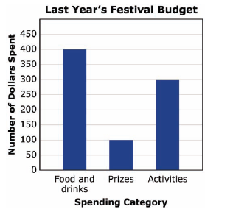
This year’s budget has been increased to $1600. The fraction of
the money used for each spending category should be the same
as the fraction of the money used for each category last year.

Write a summary of the changes to the budget. The summary
must include—

• a bar graph showing the dollar amounts that will be spent in
each category (be sure to include a title and labels)

• a description of the steps used to find each dollar amount shown in the bar graph

Part B
Food and Drinks
Your next task is to make decisions about the food and drinks that will be available at the festival. You need to determine the amount of food, drinks, plates, cups, and utensils that will be available for the people who attend the festival. You must also decide which types of food and drinks you will provide.

There are 75 students who will attend the festival. Each student will bring 1 guest to the festival. A total of 50 teacher and
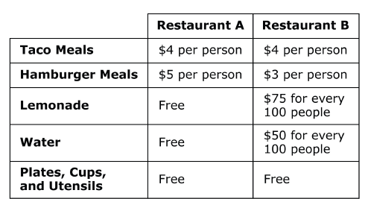
community members will also attend the festival. The table that follows shows the amounts charged for different foods and drinks by two different restaurants.

Guidelines:
• You must choose 1 restaurant to provide the food and drinks for the festival. You must also choose 1 meal type.
• You may choose 1 or 2 drinks.
• You must make sure you have enough money in your budget for the choices you make.
The principal of the school needs to approve all committee decisions. Write a note to the principal that identifies the restaurant you have chosen and clearly explains why the restaurant is the better value.
Your note should include—
• the total number of people attending the festival
• the calculated price for using that restaurant and how that price was calculated
• how you determined that the restaurant you chose was the better value

Part C
Make the Dessert
Parents have volunteered to provide cookies for the festival. One parent will buy the ingredients and then bake the cookies. The parent wants to be sure she has enough of each ingredient available to make cookies for all participants. The parent asks you to determine the amount needed for each item in the recipe shown below.

Fill in the list to the right with the amount needed for each item. Remember to think about the total number of people who will attend the festival.
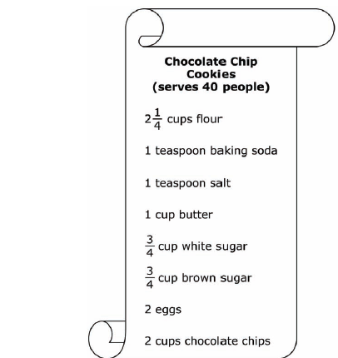
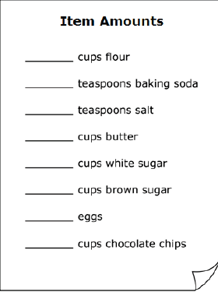

Use the space below to show or explain in words how you calculated the amount of flour needed.

Use the space below to show or explain in words how you calculated the amount of brown sugar needed.

Part D
Schedule of Activities
The school festival will start at 11:00 A.M. on Saturday. The list below shows the amounts of time each activity should last. Finish filling out the schedule below so there are no gaps in time. Also, none of the activities can happen at the same time.
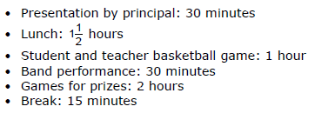
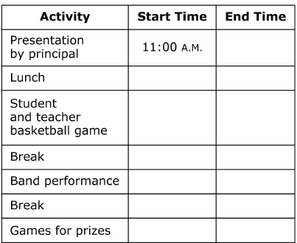

Games and Prizes
Part E
Each time a student wins a game, he or she will get a prize. You will use the money in your budget to buy 4 boxes of prizes. You will spend the same amount of money on each box of prizes. Attach a price tag to each box below to show the amount of money you will spend to buy the prizes in it.

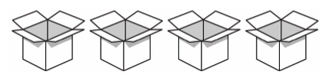

Show the steps used or explain how you found the price for each box of prizes in the space below.

Each box contains 90 prizes. The prizes will be split evenly among the 3 games. The names of the three games students will be able to play for prizes are shown below.

1. Fishing for Sharks
2. Pie the Teacher
3. Frog Jumping

Draw a model below to show both the number of boxes and the number of prizes that will be used for each game. Be sure to label what each part represents.

