3rd Grade ELA and Math
Discussion Points:

What are the outcomes that are expected of students from this task?

What are the specific student learning objectives?

Are the issues in this task real to your students?

What student product(s) and/or performances will provide evidence of student attainment of outcomes?

Do students have a choice regarding products and/or performances?

List the skills your students will need in order to be successful on this test.

What activities will you need to do for your students to be prepared for this task?

ELA Example: Dental Health (100 minutes)
Reading 1: Cavities
Our mouth is a busy place. Bacteria - tiny colonies of living organisms are constantly on the move on your teeth, gums, lips and tongue. Having bacteria in your mouth is a normal thing. While some of the bacteria can be harmful, most are not and some are even helpful.
Certain types of bacteria, however, can attach themselves to hard surfaces like the enamel that covers your teeth. If they're not removed, they multiply and grow in number until a colony forms. More bacteria of different types attach to the colony already growing on the tooth enamel. Proteins that are present in your saliva (spit) also mix in and the bacteria colony becomes a whitish film on the tooth. This film is called plaque, and it's what causes cavities.
The Role of Sugar
Sugar plays a harmful role in tooth decay. The bacteria that form together to become plaque use sugar as a form of energy. They multiply faster and the plaque grows in size and thickness. Some of the bacteria turn the sugar into a kind of glue that they use to stick themselves to the tooth surface. This makes it harder for the bacteria to get washed away with your saliva.
Severe Dental Decay
The hard, outside covering of your teeth is called enamel. Enamel is very hard, mainly because it contains durable mineral salts, like calcium. Mineral salts in your saliva help add to the hardness of your teeth. Mineral salts, however, are prone to attack by acids. Acid causes them to break down.
The plaque that forms on your teeth and doesn't get washed away by saliva or brushed away by your toothbrush produces acid as it eats up sugar. This acid is produced inside the plaque and can't be easily washed away by your saliva. The acid dissolves the minerals that make your tooth enamel hard. The surface of the enamel becomes porous - tiny holes appear. After a while, the acid causes the tiny holes in the enamel to get bigger until one large hole appears. This is a cavity. It's important to see your dentist before a cavity forms so that the plaque you can't reach with your toothbrush or floss can be removed.
Why Does It Take So Long to Hurt
Nerve fibres, the way that pain is sent through the body, aren't present in tooth enamel. While the acid is attacking the enamel, you can't feel a thing. Once the acid has begun to create a cavity and attacks the dentin under the enamel, the nerve fibres begin to send out a message that something is wrong. But by then, you have tooth decay. That's why it's important to have regular, preventive dental check-ups. Don't wait until it hurts!
Reading 2: What Happens at the Dentist's Office?
After your name is called in the waiting room, you'll go into an exam room and sit down in a big, comfortable chair that is like a huge recliner. The chair will have a place to rest your head and lots of room for you to stretch out your legs. Next to the chair may be a little sink with a cup that you can use to rinse out your mouth as your teeth are being cleaned. During the exam, your teeth will be cleaned, flossed, and checked for cavities.

Cleaning and Flossing
One of the first people you'll meet at the dentist's office is the dental hygienist (say: hi-jeh-nist). A dental hygienist is a person who knows all about keeping teeth and gums clean and healthy.
The dental hygienist will look inside your mouth to make sure your teeth are growing properly and your gums are healthy. A bright, overhead light will shine down into your mouth like a giant flashlight so the dental hygienist can get a good look inside your mouth.
The dental hygienist will clean and polish your teeth, using tiny dental tools like a tooth scraper, mirror, and special toothbrush. The tooth scraper removes plaque (say: plak) from your teeth. Plaque is a thin, sticky layer that coats your teeth and contains bacteria (say: bak-teer-ee-uh) that grow on your teeth over time. Plaque that isn't removed from your teeth can cause decay, or a cavity (say: kah-vuh-tee).
Next comes brushing and flossing. The dental hygienist will brush your teeth with a special toothbrush and toothpaste. The toothbrush has a small, round tip that moves around and around to clean your teeth. The toothpaste might taste like your own toothpaste at home, but it will feel a little grittier — almost like sand.
Then the dental hygienist will floss your teeth and show you the proper way to brush and floss your teeth at home. Flossing involves using a piece of waxy string called dental floss to get in between your teeth and remove food particles that your brush can't reach.

Checking for Cavities
During your visit, the dental hygienist will take X-rays, or pictures, of your teeth. X-rays are like superhuman vision. They can show cavities hiding between your teeth and problems beneath your gums. A cavity is a decayed, or rotted, part of a tooth.
It does not hurt to get an X-ray and it takes only a few seconds. The dental hygienist will place a thick blanket over your chest (to protect your body from the high-energy waves) and put a piece of plastic (that holds the X-ray film) into your mouth. As you gently bite down on the plastic, you'll have to be very still for a few seconds while the dental hygienist snaps the picture.

Meeting the Dentist
The dentist will look at all of your teeth and check your gums to make sure they're strong and healthy. The dentist will also check the way your top and bottom teeth work together. This is called your bite. If there might be a problem with your bite, you may be referred to an orthodontist (say: or-tho-don-tist). This is a doctor who specializes in correcting the shape or positions of all your teeth through orthodontia, or braces. The dentist will study your X-rays (looking for cavities or other problems) and ask if you have any questions about your teeth. Your dentist may also prescribe fluoride drops or tablets for you to take every day at home.

Presents From the Dentist!
When your checkup is over, the dentist usually will have a present for you! The gift is often a free toothbrush or dental floss to use at home or some sugar-free gum.
Student Directions:
Part 1 (35 minutes). Your assignment: You will watch an informational video about brushing your teeth and read two articles about dental health, taking notes on these sources, and then write an informational essay about dental health.
(Brushing Your teeth - video) http://www.ada.org/3813.aspx

Questions
Use the remaining time to answer the questions below. Your answers to these questions will be scored. Also, they will help you think about the sources you’ve read and viewed, which should help you write your essay. You may click on the appropriate buttons to refer to the sources when you think it would be helpful. You may also refer to your notes.
1. According to the video and the articles, what are the most important steps in taking care of your teeth? Use details from the sources to support your answer.
2. Explain why both the video and the articles help you understand how to care for your teeth. Use details from the sources to support your answer.
3. What do you think is the most important thing to do to keep your teeth healthy? Use details from the sources to support your answer.

Part 2 (70 minutes)
You will now have 70 minutes to review your notes and sources, plan, draft, and revise your essay. While you may use your notes and refer to the sources, you must work on your own. You may also refer to the answers you wrote to earlier questions, but you cannot change those answers. Now read your assignment and the information about how your essay will be scored, and then begin your work.

Your Assignment
Write an informational essay explaining what a person should do to have good dental health. Include details from the video and articles to support your ideas.

How your essay will be scored: The people scoring your essay will be assigning scores for
1. Statement of Purpose/Focus—how well you clearly state and maintain your controlling idea or main idea
2. Organization – how well the ideas progress from the introduction to the conclusion using effective transitions and how well you stay on topic throughout the essay
3. Elaboration of Evidence – how well you provide evidence from sources about your topic and elaborate with specific information
4. Language and Vocabulary – how well you effectively express ideas using precise language that is appropriate for your audience and purpose
5. Conventions – how well you follow the rules of usage, punctuation, capitalization, and spelling.

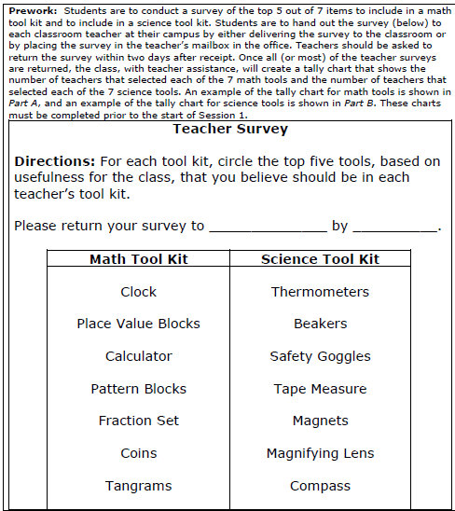
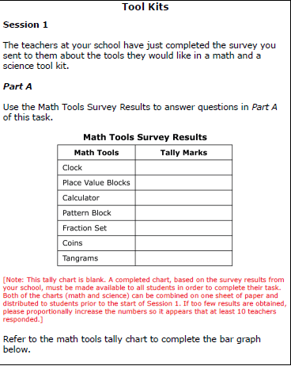
Math Question: Time is 80 to 100 minutes

